**Sonar Jenkins Configuration:**

**Steps:**

1. **Add the Sonar plugin and all the dependency plugin.**

**Plugins**

Jenkins -> Manage Jenkins -> Manage Plugins ->advanced

Install **SonarQube Plugin** and dependency plugins to install software successfully

From this link <https://wiki.jenkins-ci.org/display/JENKINS/SonarQube+plugin>

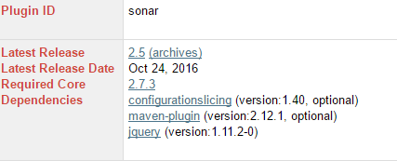

Note:-Make sure that all the dependencies plugins must be added

**Initial Setup**

After installation the initial steps to be done to configure the projects

Go to Jenkins->Manage Jenkins ->Manage Nodes->Master->Configure->Add

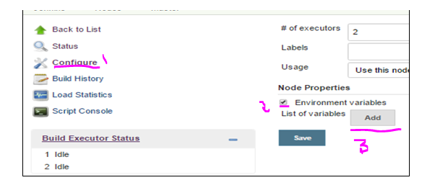

Set Environmental variables as follows

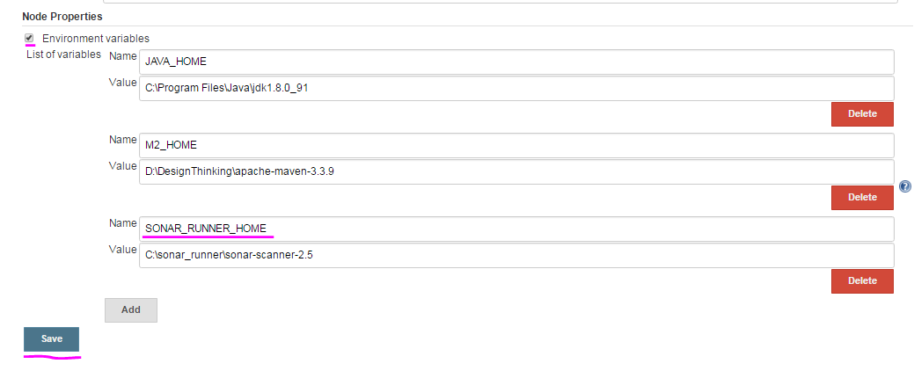

# Go to Jenkins->Manage Jenkins -> Global Tool Configuration

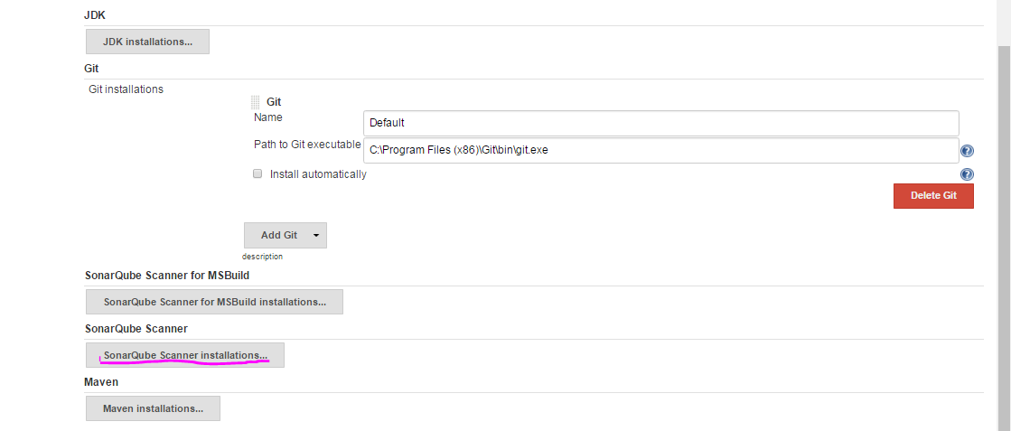

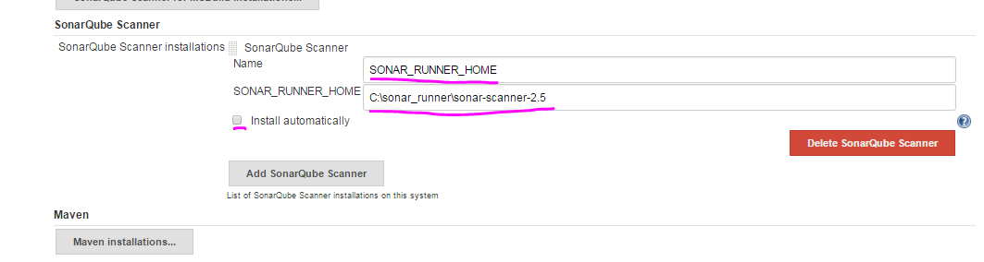

Set the sonar runner home path and also uncheck the install automatically check box and save.

1. Go to manage Jenkins🡪configuration system

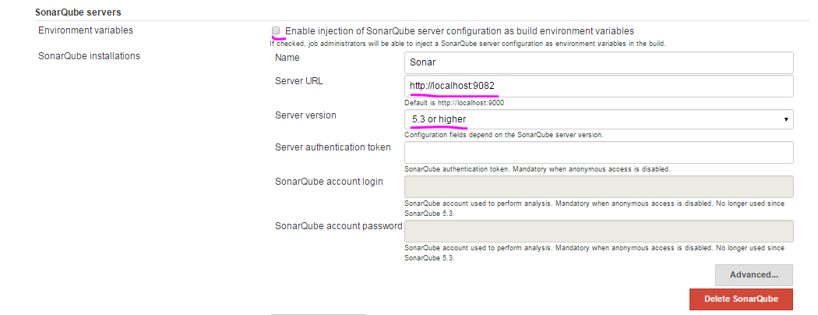

Server URL: URL in which SonarQube server is running

Note :-server should be in running condition

1. **New Project.**

Create **New item->freestyle project**

1. Under **Advanced Project Options**

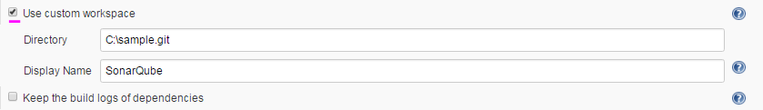

**Directory:** Mention the custom workspace directory.

**Display Name**: Display name of the project

1. **Build**

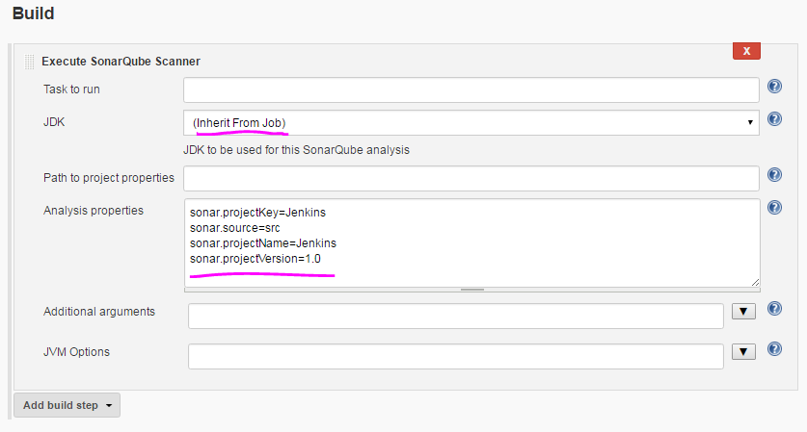

Note: 1. JDk (keep it as inherit from job)

2. Analysis properties(property which is mentioned in the sonar-runner. Properties)

->Save->BuildNow

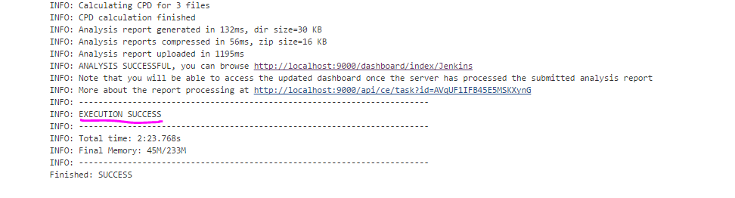

We can able to see the report by clicking the link shown above.